Lab 06: Deciphering File Formats

CYBR 688: Software Reverse Engineering

Team Members: Sairam Bokka, Ethan Hart

Introduction:
In this lab, we will analyze a simple multiplayer maze game implemented in a client-server model to understand undocumented data formats (file formats, protocols, compression algorithms, etc.). We will document the protocol and provide software artifacts that could help a developer write an application that communicates via that protocol. We will also write a custom client to communicate with the server and play the game without human input.

Materials:
-Licensed copy of Linux (Ubuntu Virtual Machine used for this lab)
-Ghidra suite for dynamic analysis
-Wireshark
-Python3 installed on your machine

Understanding the Rules of the Game:
This is a simple multiplayer maze game implemented in a client-server model. The server is a dedicated server and implements the rules of the game. Each player uses a client to communicate with the server and participate in the game.
The goal is to be the first player to reach the exit of the maze. The starting position is the top-left space, and the finish is always the bottom-right space. No two players may occupy the same space at the same time. Thus, at the beginning of the game, higher-numbered players are placed to the right of the lower-numbered players. This may seem to create an unfair advantage, but players can jump over walls in the game.
Each player is given three jumps. Jumps may be used to pass over a wall and/or move past another player. Jumping to a space outside the maze boundary is not allowed. Jumping where there is neither a wall nor another player is not allowed. Walking through a wall or another player is not allowed. If you attempt an illegal move, you lose that turn. Attempting to jump a fourth time does not cause you to lose your turn.
Issue movement commands by typing one of W, A, S, or D when it is your turn. Lowercase values indicate walking. Upper-case values indicate jumping. An upper-case L or Ctrl-C will leave the game.
Players may enter and leave the game at will. When a player enters or re-enters, the token is placed in the top-left space or an unoccupied space to the right.
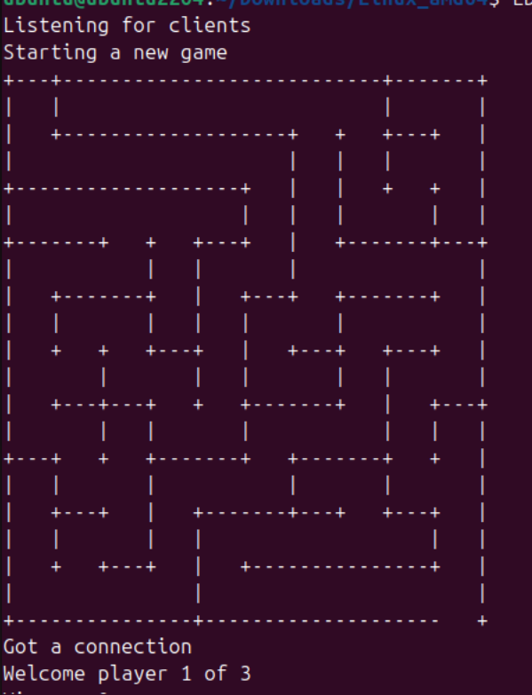
Figure 1: Multiplayer Game Server
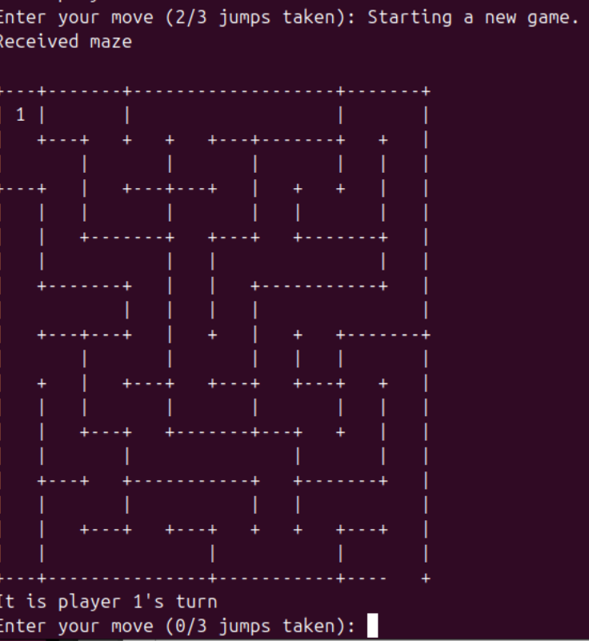
Figure 2: Multiplayer Game Client

Procedure

Reverse Engineering:
- We will start this section by capturing the network capture going back and forth from the client and server using Wireshark. We start Wireshark in loopback mode and capture the network packets for the initialization of both client and server.
- Once we connect the client to the server, we have captured some network packets from the client to the server and vice versa. The server is listening to the client on port 8008.

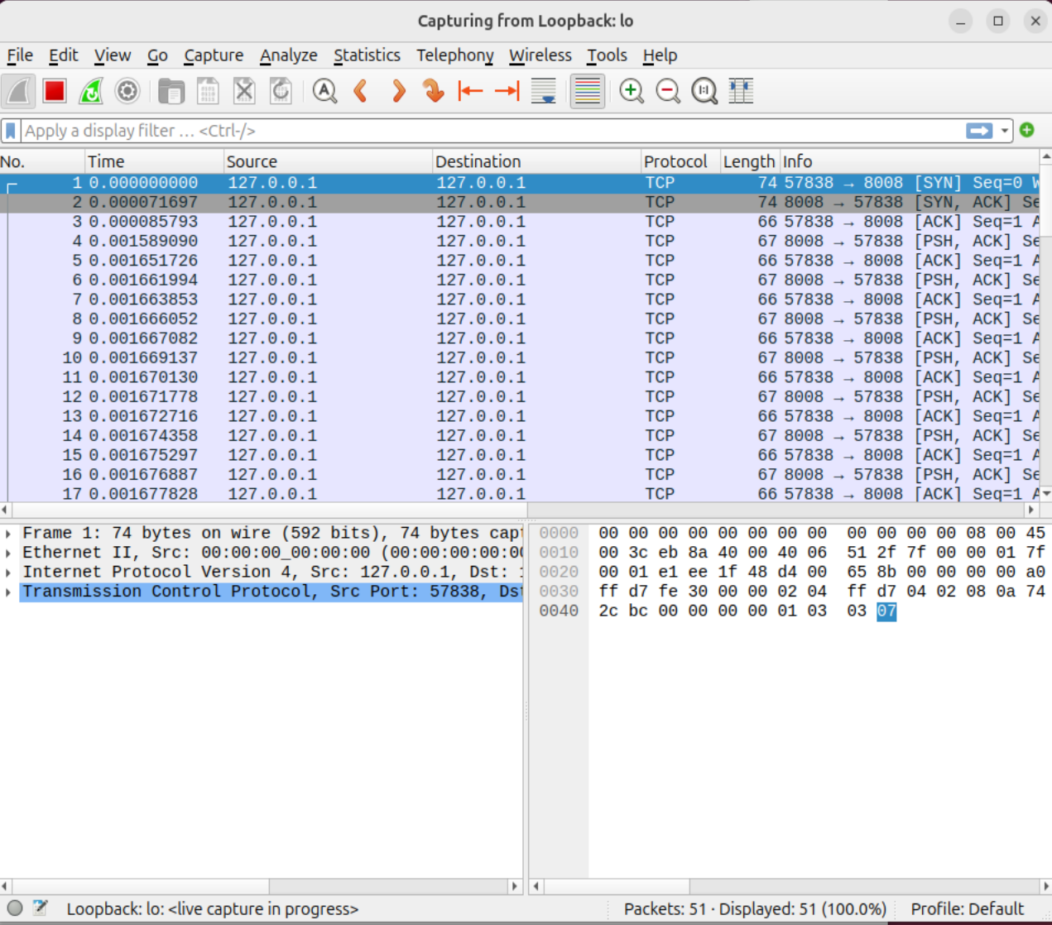
This figure shows a Wireshark capture on the loopback interface. The capture shows packets sent to and from the server and client.

- We can follow the TCP stream from client to server to see the communication made between client and server.
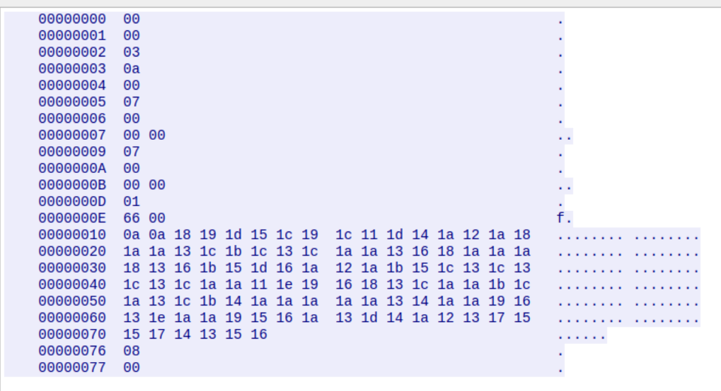
This is a hex dump, where we can see that the server is not sending anything to the client in plain text.

- We will set up a socket using Python and try sending the hexadecimal data to see what part of the stream initializes the client and decodes the hex.
- After setting up a socket with the client, we analyze the messages of the client and decode the hex stream one by one. By saving the hexadecimal dump from Wireshark, we can use our fake Python server to send the same data from the hexadecimal dump and map byte sequences to actions from the client.
- Some silent messages can be decoded by static analysis of the client using Ghidra. Looking at the decompiled code in Ghidra, cases are represented by byte values.

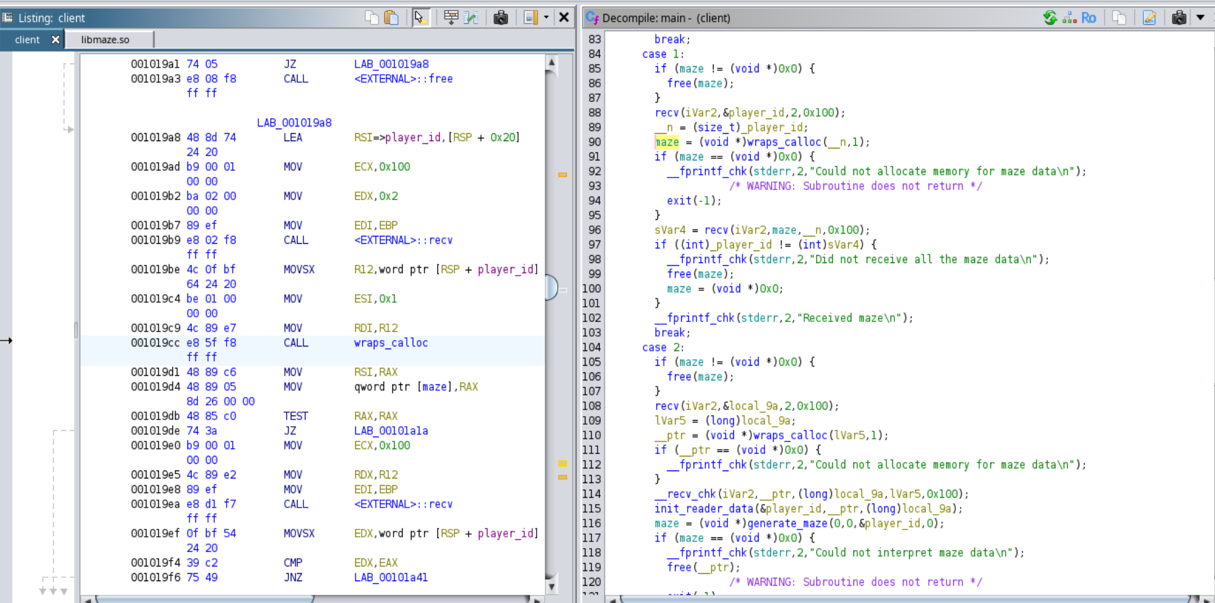
Ghidra disassembly and decompilation demonstrating how the original client handles messages from the server.

Byte Sequence Documentation
This documentation explains the byte sequence, which appears to be for a game setup where players join, and messages and game states are initialized, specifically for a multi-player maze game setup.

T
Key
- Byte Offset: Shows the position in the file.
- Hex Value: The actual data in hexadecimal format.
- Description: Explanation of what each byte or group of bytes represents.
Breakdown

0x00000000 - 0x00000002: Welcome Message
- 0x00000000 - 0x00000001: 00 00
  - Indicates the beginning of the welcome message sequence for Player 1.
- 0x00000002: 03
  - Specifies the total number of players (3 players).
  - Interpretation: 00 is Player 1, and 03 is the total players.
Message: "Welcome Player 1 of 3" (based on the first three bytes)

0x00000003 - 0x00000004: Player Join Message
- 0x00000003: 0a
  - Indicates a player has joined.
- 0x00000004: 00
  - Specifies Player 1 (encoded as 00).
Message: "Player 1 has joined"

0x00000005 - 0x00000007: Player Position Information
- 0x00000005: 07
  - Likely denotes a command related to player position or status update.
- 0x00000006 - 0x00000007: 00 00
  - Could represent a column and row position or a status indicator for Player 1 in the game grid (exact usage may vary depending on the game engine).

0x00000009 - 0x0000000B: Repeated Position Information
- 0x00000009: 07
  - Repeats command 07 seen earlier, potentially for another positional update.
- 0x0000000A - 0x0000000B: 00 00
  - Repeated 00 00 could signify the starting or reset position of a player.

0x0000000D - 0x00000077: Maze Data
This sequence represents a compressed or encoded maze layout and possibly character movements.
- 0x0000000D: 01
  - Likely a command or identifier for the start of maze data.
- 0x0000000E - 0x00000077: 66 00 0a 0a 18 18 19 15 ... 12
  - A long sequence of bytes appears to be encoded maze data, where each byte likely represents a cell in the maze with unique attributes.
  - 0a, 0a at the start represent size of the maze(10x10 in this case).
  - Values like 18, 1c, etc., could represent walls, open paths, or special points of interest within the maze.
Interpretation: Maze layout data where each byte might encode specific features or types of tiles.

0x00000076 - 0x00000077: Maze Command or End Marker
- 0x00000076: 08
  - Potentially a command to finalize or print the maze layout.
- 0x00000077: 00
  - Could signify the end of data or reset the state for the maze output.

Forward Engineering

The next step in this lab involves creating a bot client in Python that can interact with the server and respond to the messages the server sends. The client has responses for the following server responses:
- MSG_WELCOME = 0
  - Definition: handles welcome message which receives:
            - 1 byte: my_player_id — The player's ID.
            - 1 byte: max_players — The total number of players in the game.
- MSG_MAZE_DATA = 1:
  - Definition: handles maze data which receives:
            - 2 bytes: size — The size of the maze data (often ignored but can denote total size of remaining data).
            - 1 byte: col_count — Number of columns in the maze.
            - 1 byte: row_count — Number of rows in the maze.
- MSG_ILLEGAL_MOVE = 5
  - Definition: handles illegal moves
- MSG_NOT_YOUR_TURN = 6
  - Definition: handles incorrect turns
- MSG_PLAYER_POS = 7
  - Definition: handles player position which receives:
            - 1 byte: player_id — The ID of the player whose position is updated.
            - 1 byte: col — The player's new column position.
            - 1 byte: row — The player's new row position.
- MSG_PLAYER_TURN = 8
  - Definition: handles player turn (Opponent vs itself) which receives:
            - 1 byte: player_id — The ID of the player whose turn it is.
- MSG_PLAYER_JOINED = 10
  - Definition: handles if a new player has joined which receives:
            - 1 byte: player_id — The ID of the player who joined.
- MSG_PLAYER_LEFT = 11
  - Definition: handles if a player left the server which receives:
            - 1 byte: player_id — The ID of the player who left.
- MSG_PLAYER_WINS = 12
  - Definition: handles if we win which receives:
            - 1 byte: player_id — The ID of the player who won the game.
- MSG_NEW_GAME = 13
  - Definition: handles a new game message
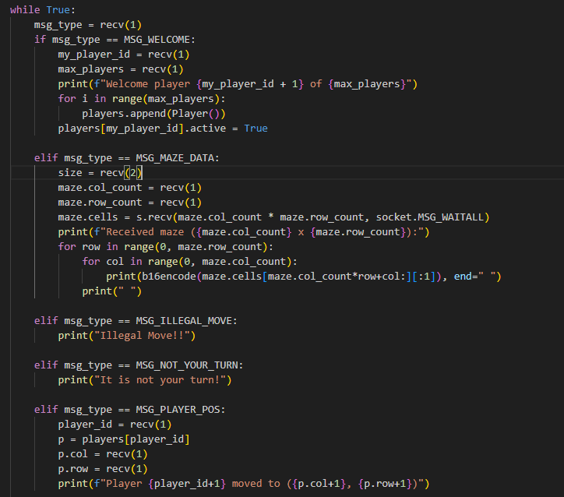
This figure shows some of the responses given by the bot.py client file when provided messages from the server.

Sending Moves
As a part of interacting with the server, this bot client must be able to send moves. The loophole that we implemented was for our bot to not keep track of the number of jumps being made. So, our bot will try to beeline to the end of the maze by going all the way to the right, and to the bottom of the maze. The function that accomplishes this looks as follows:
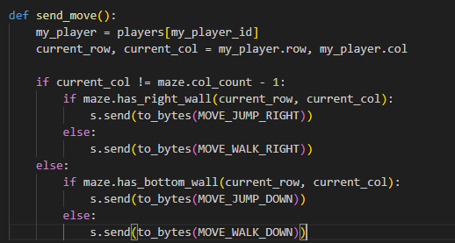
This figure shows the functionality of how bot.py sends moves.

Result
When the original server is run and the original client and bot client are connected, the user can manually play against the bot client. The following screenshots illustrate the sameness in functionality between the original client and the bot client. Note that the bot client interacts with the server in the same way as the original client.
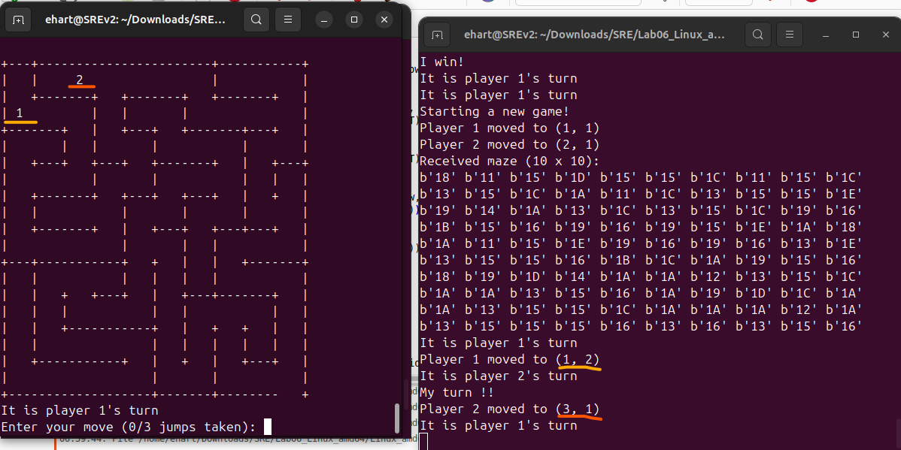
Example 1: The beginning of a game with a human controlling the client on the left against the bot client on the right.

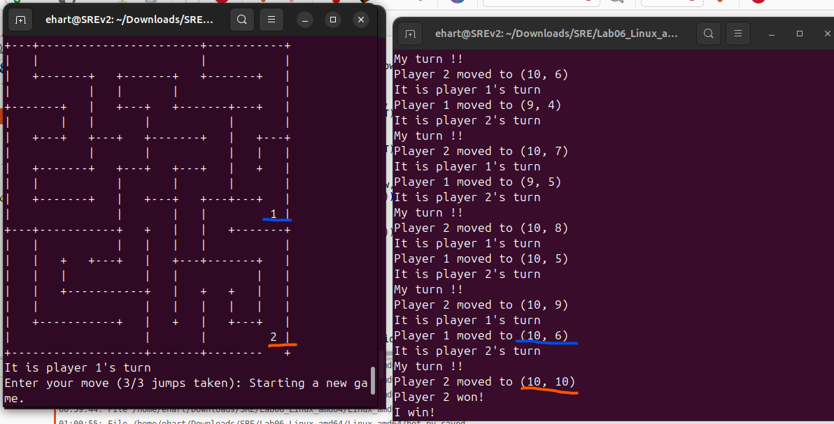
Example 2: The end of the game where the bot client on the right has won against the human client on the right.

Conclusion:
We successfully documented and reverse-engineered a client-server multiplayer protocol and created a bot that uses an exploit in the game’s design to win the game in a low number of turns. We used Wireshark to inspect the traffic between the original client and the server. We then used Python’s socket functionality to mimic the server with the intent of understanding what the byte sequences sent by the original server meant. We used Ghidra to examine silent messages using static analysis. With our knowledge of the meanings behind the byte sequences sent by the server, we were able to create a bot client mimicking the functionality of the original client that responded to server messages appropriately to advance the game state and win the game.

